GOLDEN EAGLE WRESTLING
COMPETITION CAMP
July 6, 7, 8, 9, 10, 2016
Medical Release Form
PERTINENT MEDICAL INFORMATION (please print)

Athlete_______________________________ Grade_____

Parent/Guardian _______________________________

Work Phone _____________ Home Phone _________

Address ______________________________________

City _________________________ State ___ Zip _____
(Verify by initialing)
_____ I give permission for medical treatment; release of medical information and am responsible for medical expenses.
_____ I authorize the staff of the Golden Eagle Wrestling Camp to render emergency medical care for my/our child. We further authorize the staff to obtain medical care at a hospital or by a private physician should, in the judgment of the staff, it be necessary. The Staff will use the 911 emergency care if necessary.
_____ I AUTHORIZE release of any medical information to the medical staff and emergency workers that is required to treat the above named participant.
_____ I UNDERSTAND that any changes resulting from this medical treatment will be billed to me at my address or to my medical insurance carrier which is:
INSURANCE:
Company ___________________________________

Policy # _______________________

Address ____________________________________

City ______________________ State ___ Zip ______

Parent’s signature _____________________________

Wrestler signature ____________________________

COMPLETE THIS FORM & BRING TO REGISTRATION.
*MUST BE SIGNED BY PARENT/GUARDIAN.
ACCOMMODATIONS
TECHNIQUE &
COMPETITION CAMP cWRESTLING CAMP
TRAVELODGE
- (3miles) 877 East D St
- Lemoore 559 924 1261 Restaurant on site.
July 6, 7, 8, 9, 10, 2016
BEST WESTERN INN & SUITES
- (3 miles) 820 E Bush St.
- Lemoore 559 924 3200 Restaurant across St.

MOTEL 6 (3 miles off 198 FWY)
- 1290 Sierra Cr., Lemoore 559 925 6100
Restaurants - 3 to 4 miles


NATIONAL ANTHEM

O say can you see by the dawn's early light,
What so proudly we hailed at the twilight's last gleaming,
Whose broad stripes and bright stars through the perilous fight,
O'er the ramparts we watched, were so gallantly streaming?
And the rockets' red glare, the bombs bursting in air,
Gave proof through the night that our flag was still there;
O say does that star-spangled banner yet wave,
O'er the land of the free and the home of the brave?



Golden Eagle Wrestling
West Hills College Sports Arena
555 College Ave.
Lemoore, CA 93245
Kent Olson, Head Coach
559 925 3689 559 707 5620 fax 559 924 0429
kentolson@whccd.edu; farmboyz@hotmail.com
CLINICIANS

CHRIS PENDLETON
Assist. Coach Arizona State University

JAMILL KELLY
Assoc. Head Coach Stanford University

ZACH SANDERS
Assoc. Coach University of Minnesota

TROY STEINER
Head Coach Fresno State University

JASON WELCH
Northwestern University

JON READER
Asst. Coach South Dakota U

STAFF
Kent Olson, WHCL Head Coach
Howard Zink, Asst. Coach, Golden Eagle Wrestlers

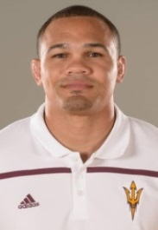
CLINICIANS

CHRIS PENDLETON
Asst. Coach
Arizona State University

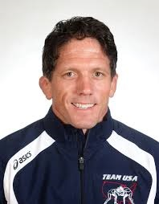
TROY STEINER
Head Coach
Fresno State University

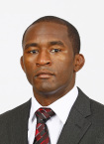

JAMILL KELLY
Assoc. Head Coach Stanford University
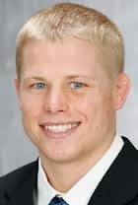

ZACH SANDERS
Assoc. Coach
University of Minnesota
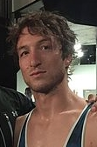
__________________________________________________

JASON WELCH
Northwestern University

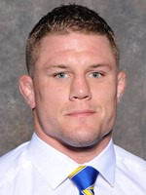

JON READER
Asst. Coach
S Dakota University
2015 Tournament Teams 1st - 3rd

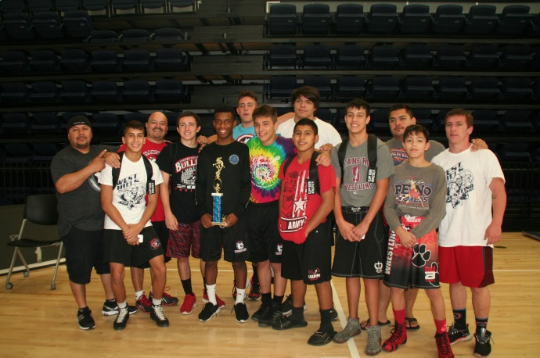
2015 CHAMPS! HANFORD BULLPUPS
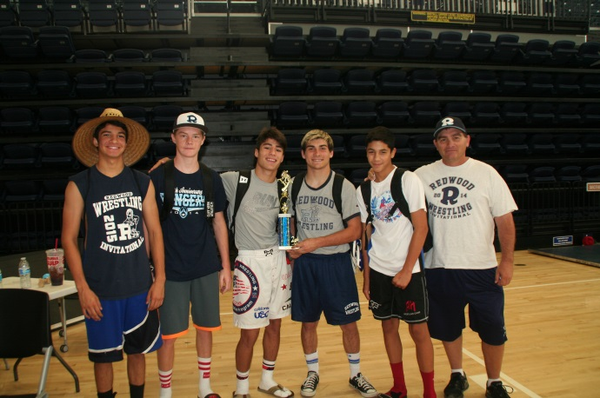
2ND REDWOOD RANGERS
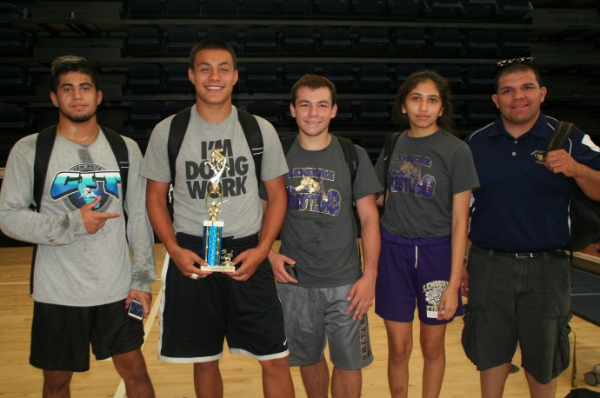
3RD LEMOORE TIGERS

K-12 COMPETITION & TECHNIQUE CAMP
JULY 6, 7, 8, 9, 10, 2016
(COMPLETE & BRING FORM TO CAMP REGISTRATION)
Location: West Hills College Lemoore
Golden Eagle Sports Arena, 555 College Ave. Lemoore, 93245
Contact: Kent Olson, Head Wrestling Coach
559 924 707 5620, 559 925 3689, 559 924 9194 (home)
FEE: $600 per team not to exceed *15 wrestlers.
*A team will be comprised of actual school/club members.
No combining or pulling together wrestlers from other
schools / teams / clubs
$100 – each additional wrestler on team. *
(fee is whether attending one day or entire camp)

JULY 6 8:00am REGISTRATION BEGINS
Make check to: WHCL Wrestling Foundation

DAILY SESSIONS
9:00am – 12 noon 3 hour clinic
12 noon – 1:00pm Lunch
1:00pm – 5:00pm 4 dual meets
5:00pm – 6:00pm Individual competition
REGISTRATION FORM (Complete back-side also) Please print
TEAM ____________________________________

Coach ____________________________________

Address __________________________________

_________________________________Zip______

Phone ____________________________________

Coach Signature ____________________________

INDIVIDUAL _______________________________

Address ___________________________________

_________________________________Zip______

Phone _____________________________________

Parent Signature _____________________________
Wrestler Signature ___________________________

